USER INTERFACE AND DESIGN

EXPERIMENT – 8

Roll No:240701550

Aim:
The aim is to create storyboards representing the user flow for a mobile application, including categorized browsing, using Balsamiq.

Procedure
- Tool Used:
Balsamiq Wireframes (https://balsamiq.com)
- Project Creation:
I started a new mobile project and utilized the "Hand-drawn" skin to focus on the structural layout and user logic.
- Component Selection:
I used the UI library to select standard mobile components like Search Bars, Grids, List Items, Media Cards, and Navigation Bars.
- Flow Integration:
I added a specific "Music Categories / Genres" layer to simulate how a user transitions from browsing general content to selecting specific songs, albums, or playlists.
- Design Focus:
The wireframes were kept clean and simple, ensuring that navigation controls like "Play", "Pause", and "Add to Playlist" are prominently placed for easy interaction.

User Flow
- Home Screen – Starting point for exploring recommended music, playlists, and recently played songs.
- Music Categories / Genres – Helps users browse music by type (e.g., Pop, Hip-Hop, Classical, Podcasts).
- Search / Song List – Shows songs, albums, or artists based on user search or selected category with details like title and artist.
- Song Details / Player – Displays currently playing song with controls and album information.
- Playlist / Library – Allows users to view saved songs and playlists.
- Playback Confirmation – Confirms that the song is playing or added to playlist successfully.

Detailed Screen Analysis
1. Home Screen
● Components: Search Bar, Recommended Playlists, Recently Played Section, and Featured Albums.
● Purpose: To engage the user and provide quick access to personalized music content.

2. Music Categories / Genres Screen
● Components:
○ Grid view of music genres (e.g., Pop, Rock, Tamil, Podcasts).
○ Icons or album thumbnails representing each category.
○ Search filter to find genres quickly.
● Purpose: To prevent information overload by allowing users to browse music based on their preferences.

3. Search / Song List Screen
● Components: Song thumbnails, Titles, Artist names, and quick "Play" button.
● Purpose: To allow users to browse and select songs or albums easily.

4. Song Details / Player Screen
● Components: Large Album Image, Song Title, Artist Name, Playback Controls (Play/Pause/Next), Progress Bar.
● Purpose: To provide full control over music playback and enhance listening experience.

5. Playlist / Library Screen
● Components: Saved Songs list, Playlist sections, and "Add to Playlist" option.
● Purpose: To organize and access user’s saved music collection.

6. Playback Confirmation Screen
● Components: “Now Playing” indicator, Song details, and playback status.
● Purpose: To confirm that the song is playing or added successfully to the playlist.

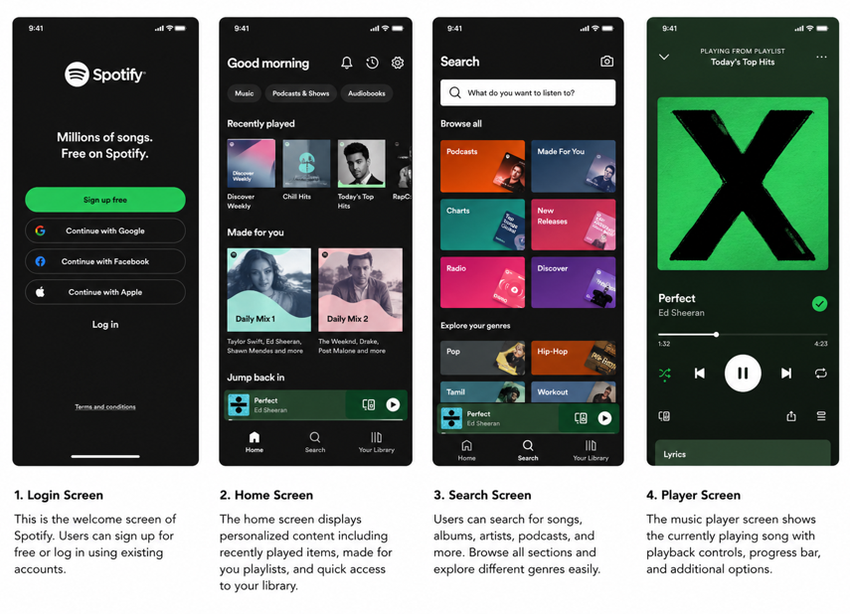

Conclusion
This experiment helped in understanding how user flows are designed in a music streaming application like Spotify. By creating wireframes and storyboards, it became easier to visualize how users navigate through different screens such as home, search, and music player.
.

